Abstract Objective: Get baseline measures of visual electrophysiology for specific stimuli that can help to characterize visual cortex activation in healthy subjects. Method: Different stimuli was showed and analyzed in order to identify which have the most significant difference in power spectrum measures. A study of measures repeated was made for this characterization. Results: All the stimuli presented significant difference between resting-state eyes closed and the stimulus for delta, theta and alpha bands, beta band does not allow to differentiate stimulation states in any test. It was not possible to obtain a significant difference between the stimulus and resting-state eyes open in all the recordings. Clinical Impact: With these stimuli and baseline in some measures will be possible to compare the result in patient with neuro-ophthalmological disorders and in rehabilitation therapy.
Baseline measures visual cortex activation with EEG: application in neuro-rehabilitation
Ortega R. Daniela¹, Ochoa G. John², and Suárez E. Juan³

Keywords — Electroencephalography, neuro-rehabilitation, visual cortex, stimuli

INTRODUCTION
The visual system has been subdivided into many functional areas. The primary visual cortex, V1, sends input to extrastriate cortex and to visual association cortex. V4 allows color recognition [1][2][3], V5 and V3A are important for motion-sensitive [4][5], lateral occipital complex (LOC) is a higher visual area critical for object shape perception [6] and other studies have identified the visual word form area [7]. Additional to these type of functions also acuity visual, contrast sensitivity and visual field are elements of the visual system have an important role in daily life.

However, some functions of visual system can lose after stroke or traumatic brain injury (TBI) [8][9][10][11]. Ocular and visual problems are an important issue in just about every facet of stroke medicine [12]. Over the last several decades, different stimuli have been designed to measure some visual skills. In many cases, these stimuli have allowed identify the specific area for different functions and have been useful for detection of amblyopia [13], acuity visual measures [14][15], contrast sensitivity measures [16][17], color detection [1] [2], motion perception [18], etc. However, in recent studies there is not a complete characterization of all stimuli that can be a baseline for study of activation visual cortex using EEG. This measures could be useful for therapy follow-up and they are import to create an objective measure of therapy process [19].

In this paper aims to characterize EEG signals of the visual system in healthy subjects. We compare the EEG measure with different stimuli that activate some visual functional areas. Analyze was made in power spectrum measures in order to identify the base line in health subjects for future studies in patients with neuro-ophthalmological dieses.

EXPERIMENTS

Participants
Eighteen healthy volunteers (aged 20–27 years old, ten males, and eight females) participated in this study. They did not have an epilepsy, mental or physical disorders. During the whole experiment, they were seated in a comfortable chair in a slightly dimmed room about 1 m in front of the stimulation unit. All subjects completed the test in the same time. Subjects did not receive any financial reward for participating in this study. Written informed consent was obtained of all participants after explanation of the nature and possible consequences of this study.

Stimuli Conditions
Each subject was in the experiment during 40 minutes. This section explains each condition for the recordings. The stimuli were showed for binocular and monocular vision. In each subject 8 signals were acquired. Stimulus was design in python, openDesigner and psychopy and performed in a screen SyncMaster 2243 LNX . Script are open and can be used in other projects (https://github.com/danni9310/SetStimuli).

- Resting-state: 30 seconds with eyes closed and 30 seconds with eyes open for binocular and monocular vision.
- Vernier acuity was measured when a stimulus is alternated between two states. The screen is covered with a bar grating and in a second state, portions of the screen are offset. All stimuli alternated between two states at a rate of 3.75 Hz. For the swept paradigm, the size of the displacements of Vernier offset ranged from 2 to 30 cycles per degree (cpd) in logarithmic steps over a period of 10 s [20][13][21].
- Contrast sensitivity was measured by presenting a phase-reversing, 2 cpd. Contrast sweep 3.75-Hz onset-offset vertical grating space-average luminance white background screen was swept from 0.5% to 100% contrast in linear steps [22][23].
- Visual field stimulus consisted in that while the patient focuses on a central fixation point in the screen during the entire period of examination, light stimulus was repetitively presented in different parts of the space screen. [24]. Only for this stimulus, subject have attended stimulus from 50 cm distance.
- Motion perception was measured with two stimuli. First, dynamic random-dot kinematograms (RDKs) consisted of a large number of moving dots randomly positioned within a restricted area. Each dot is assigned a particular motion vector. With these stimuli, a variable percentage of dots can be moved in a single coherent (signal) direction whilst remaining dots are moved in random directions (noise) [18] [25] [26]. Second stimulus was a square white moving in different direction in the screen with black background. The subjects had to follow the movement of the square.
- Form recognition was measured while volunteers were watching universal icons for some objects. Three objects were static and 3 more was showed in real size and after it was reduced in scale.
- Read words stimulus were projected in white font onto a black screen [27][28]. Words with one, two and three syllables were showed while the words were moving right to left or left to right.
- Color detection stimulus was designed in three parts. First, basic color (red, blue, green and yellow) was performed in the screen for 5 seconds, after the same color flicker between color and black in order to change the contrast [2] and finally stroop effect was tested to maintain the concentration in the image [29].
- Image analysis was designed with 3 types of image. Four images of objects, four faces and four landscapes were shown. Each image was on the screen for five seconds.

A diagram is presented in supplementary material for explaining all condition for each stimuli.

In resting-state and stimulus Vernier acuity, contrast sensitivity, visual field and motion perception, the subjects only watched the screen, while in form recognition, read words, color detection and image analysis they should say the form they observed, read the text, mention the color and describe the image.

C. EEG Recording
An open source BCI headset and data acquisition board OpenBCI were used to acquire EEG signals from the surface of the scalp. The sampling rate was 250 Hz. According to the International 10–10 system, sensors were placed on the scalp at locations FCz, Oz, O1, O2, PO7, PO8, PO3, PO4. Additionally, two sensors were used on left and right earlobes for reference and ground signals respectively.

D. EEG Processing
The EEG recordings were band-pass filtered at 3-30 Hz in all cases with Python. Frequency spectrum were calculated for each bipolar channel by Welch's power spectral density estimate method. This processing was made with a Hamming window.
Relative power spectral in each frequency band was calculated for summation of the values for each band, delta (0-4), theta (4-8), alpha (8-13) and beta (13-30). The result was obtained for each bipolar configuration Oz-FCz, O1-FCz, O2-FCz, PO7-FCz, PO8-FCz, PO3-FCz and PO4-FCZ

E. Statistical Analysis
The data was analyzed with statistical software STATGRAPHICS. An exploratory analysis of the data was carried out and the variables were evaluated for a repeated measurements design. Factor analysis was used for dimensionality reduction.
A sphericity test was performed for each analysis. If the P value of the Mauchly test was greater than 0.05 the data complied with sphericity, otherwise the Greenhouse-Geisser Corrections was performed.

Results
An exploratory analysis on the EEG recording allowed to clean the database and determine the final signals for analysis by each type of stimulus. Table I summarizes the number of subjects analyzed for each stimulus and type of vision (binocular - B, monocular left - L and monocular right - R), 380 test was studied in this paper. The signals are available in a repository on GitHub (https://github.com/danni9310/Result_Tesis/tree/master/DataProcessing).

Relative power in each frequency band for channels Oz-FCz, O1-FCz, O2-FCz, PO7-FCz, PO8-FCz, PO3-FCz and PO4-FCZ was analyzed with a correlation matrix. The 7 channels for each band was reduced to one factor. For all reductions, these accounted for more than 90% of the variability in the original data.

TABLE I
Number of EEG recording used for each test

Stimulus | B | L | R
Vernier acuity | 15 | 16 | 16
Contrast sensitivity | 17 | 17 | 16
Visual field | 13 | 15 | 17
Motion perception (RDKs) | 11 | 13 | 12
Motion perception (Square) | 16 | 17 | 13
Form recognition | 13 | 13 | 13
Read words | 11 | 10 | 11
Color detection | 13 | 14 | 13
Image description | 15 | 14 | 16
The four factors (F) for each band delta (δ), theta (θ), alpha (α) and beta (β) was used in measures repeated analysis. Table II shows the results for p-value in Mauchly's Sphericity Test and the condition in which there is significant difference. Each stimulus (S) is compared with resting-state eyes closed (EC) and resting-state eyes open (EO).

This result shows that the beta band does not allow to differentiate between any of the conditions, while the delta, theta, and alpha bands [30] present significant differences for closed eyes and open eyes, as well as for closed eyes and the stimulus [31].

Differentiating between open eyes and closed eyes was not possible for all records. There is a significant difference for the alpha band in the sharpness and contrast stimuli mainly because in these stimuli there is a specific stimulation frequency that increases the information for the beta band but decreases for alpha band. For this reason, alpha manages to discriminate the type of stimulus.

However, in the other stimuli it is not easy to separate the three condition. Figure 1 shows Least Significant Difference (LSD) values for each band for color stimulus. For delta, theta and alpha band it is possible separate two condition. Delta band does not show difference. These figure are similar for all stimuli. Also it is possible to identify that power in alpha power was stronger in the EC than in the EO [31] while delta and theta were weaker in the EC than in the EO.

TABLE II
p-value in Mauchly's Sphericity Test for each stimulus (S), frequency band (F) and type of vision (B ,L and R)

S | F | EC vs EO |  |  | EC vs S |  |  | EO vs S |  |  | P-value
S | F | B | L | R | B | L | R | B | L | R | B | L | R
Vernier acuity | δ | * | * | * | * | * | * |  |  |  | 0.78 | 0.19 | 0.05
Vernier acuity | θ | * | * | * | * | * | * | * | * | * | 0.50 | 0.48 | 0.54
Vernier acuity | α | * | * | * | * | * | * |  | * |  | 0.26 | 0.06 | 0.00
Vernier acuity | β |  |  |  |  |  |  |  |  |  | 0.03 | 0.00 | 0.00
Contrast sensitivity | δ | * | * | * | * | * | * |  |  |  | 0.86 | 0.73 | 0.34
Contrast sensitivity | θ | * | * | * | * | * | * | * | * | * | 0.10 | 0.07 | 0.94
Contrast sensitivity | α | * | * | * | * | * | * | * |  |  | 0.08 | 0.06 | 0.01
Contrast sensitivity | β |  |  |  |  |  |  |  |  |  | 0.05 | 0.00 | 0.00
Visual field | δ | * | * | * | * | * | * |  |  |  | 0.07 | 0.59 | 0.62
Visual field | θ | * | * | * | * | * | * |  |  |  | 0.07 | 0.08 | 0.18
Visual field | α | * | * | * | * | * | * |  |  |  | 0.10 | 0.02 | 0.05
Visual field | β |  |  |  |  |  |  |  |  |  | 0.00 | 0.00 | 0.00
Motion perception (RDKs) | δ | * | * | * | * | * | * | * |  |  | 0.63 | 0.50 | 0.29
Motion perception (RDKs) | θ | * | * | * | * | * | * |  |  |  | 0.26 | 0.10 | 0.17
Motion perception (RDKs) | α | * | * | * | * | * | * | * | * |  | 0.39 | 0.13 | 0.01
Motion perception (RDKs) | β |  |  |  |  |  |  |  |  |  | 0.01 | 0.05 | 0.00
Motion perception (Square) | δ | * | * | * | * | * | * |  |  |  | 0.04 | 0.20 | 0.05
Motion perception (Square) | θ | * | * | * | * | * | * | * | * |  | 0.18 | 0.28 | 0.41
Motion perception (Square) | α | * | * | * | * | * | * |  |  |  | 0.13 | 0.01 | 0.06
Motion perception (Square) | β |  |  |  |  |  |  |  |  |  | 0.00 | 0.00 | 0.07
Form recognition | δ | * | * | * | * | * | * | * | * | * | 0.16 | 0.16 | 0.26
Form recognition | θ | * | * | * | * | * | * |  |  |  | 0.37 | 0.77 | 0.09
Form recognition | α | * | * | * | * | * | * |  | * |  | 0.26 | 0.34 | 0.00
Form recognition | β |  |  |  |  |  |  |  |  |  | 0.03 | 0.05 | 0.05
Read words | δ | * | * | * | * | * | * |  |  |  | 0.60 | 0.92 | 0.22
Read words | θ | * | * | * | * | * | * |  |  |  | 0.69 | 0.44 | 0.02
Read words | α | * | * | * | * | * | * |  |  |  | 0.08 | 0.43 | 0.00
Read words | β |  |  |  |  |  |  |  |  |  | 0.03 | 0.06 | 0.06
Color detection | δ | * | * | * | * | * | * |  | * | * | 0.45 | 0.22 | 0.07
Color detection | θ | * | * | * | * | * | * |  |  |  | 0.49 | 0.15 | 0.24
Color detection | α | * | * | * | * | * | * |  |  |  | 0.65 | 0.14 | 0.09
Color detection | β |  |  |  |  |  |  |  |  |  | 0.07 | 0.06 | 0.04
Image description | δ | * | * | * | * | * | * | * | * | * | 0.08 | 0.29 | 0.80
Image description | θ | * | * | * | * | * | * |  |  |  | 0.33 | 0.81 | 0.52
Image description | α | * | * | * | * | * | * | * | * | * | 0.27 | 0.26 | 0.01
Image description | β |  |  |  |  |  |  |  |  |  | 0.00 | 0.00 | 0.13

Fig. 1. Means and 95.0 percent LSD intervals for a) delta band b) theta band c) alpha band and d) beta band

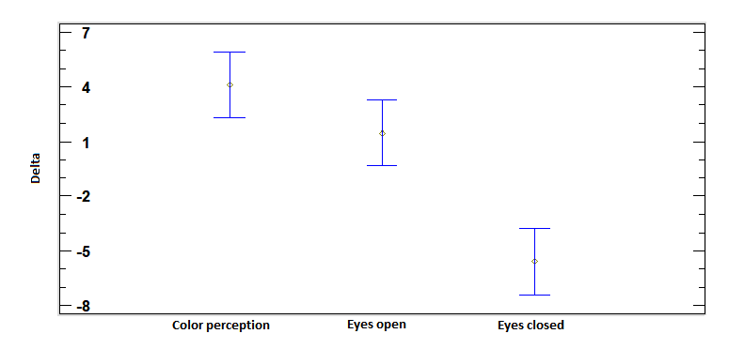
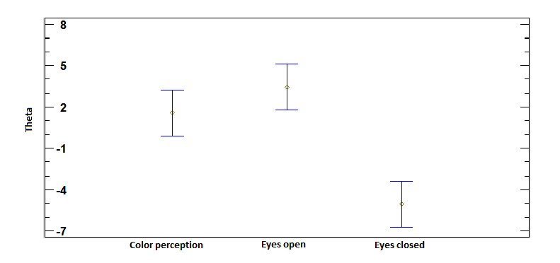
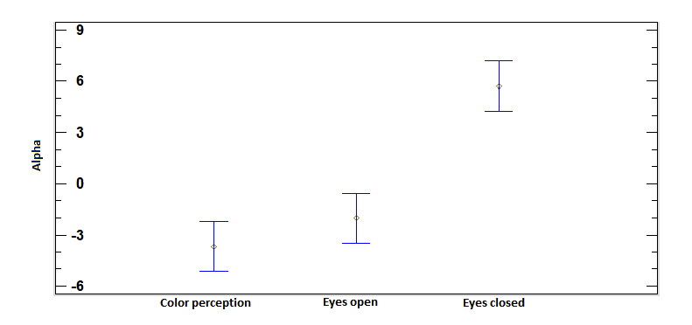
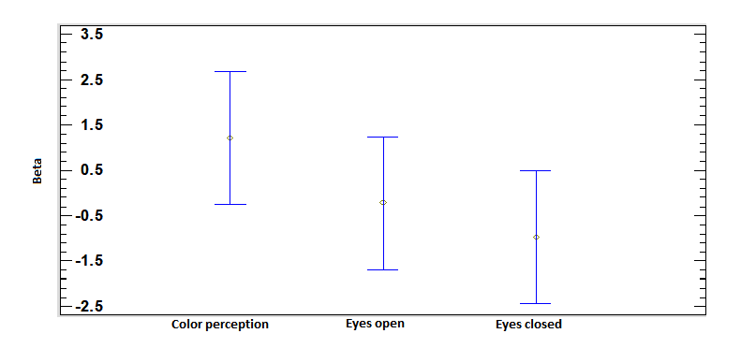

Conclusion
Our results indicated that relative delta, theta and alpha powers could be an indicator to distinguish between visual input and no visual input conditions because all the stimuli presented significant difference between resting-state eyes closed and the stimulus. Relative beta power does not allow to differentiate stimulation states in any test. It was not possible to obtain a significant difference between the stimulus and resting-state eyes open in all the recordings.

With these stimuli and baseline in some measures will be possible to compare the result in patient with neuro-ophthalmological disorders and in rehabilitation therapy.

However, future works could analyze other characterize on the signal for identify the facto, variables, or electrodes that maximize the difference between stimuli and EO.
Acknowledgment
The authors thank all the volunteers who participated in the tests for their disposition and time. The study was possible thanks to their participation.
References

[1] K. Seymour, C. W. G. Clifford, and N. K. Logothetis, “The Coding of Color , Motion , and Their Conjunction in the Human Visual Cortex,” Curr. Biol., vol. 19, no. 3, pp. 177–183, 2009.
[2] R. Shapley and M. J. Hawken, “Color in the Cortex : single- and double-opponent cells,” Vision Res., vol. 51, no. 7, pp. 701–717, 2011.
[3] A. Yoto, T. Katsuura, K. Iwanaga, and Y. Shimomura, “Effects of Object Color Stimuli on Human Brain Activities in Perception and Attention Referred to EEG Alpha Band Response,” 1999.
[4] T. H. Donner, M. Siegel, R. Oostenveld, P. Fries, M. Bauer, and A. K. Engel, “Population Activity in the Human Dorsal Pathway Predicts the Accuracy of Visual Motion Detection,” J Neurophysiol 98, vol. 98, pp. 345–359, 2007.
[5] C. S. Ho and D. E. Giaschi, “Low- and high-level first-order random-dot kinematograms : Evidence from fMRI,” Vision Res., vol. 49, no. 14, pp. 1814–1824, 2009.
[6] S. O. Murray, D. Kersten, B. A. Olshausen, P. Schrater, and D. L. Woods, “Shape perception reduces activity in human primary visual cortex,” PNAS, vol. 99, p. 23, 2002.
[7] S. Dehaene and L. Cohen, “The unique role of the visual word form area in reading,” Trends Cogn. Sci., vol. 15, no. 6, pp. 254–262, 2011.
[8] I. Pasley, S. Jobke, A. Julia Gudlin, and B. A. Sabel, “Application of Neural Plasticity for Vision Restoration after Brain Damage,” in Neuroengineering, 2008, p. 23.
[9] F. I. R. Owe et al., “Visual impairment following stroke : do stroke patients require vision assessment ?,” no. November 2008, pp. 188–193, 2009.
[10] E. Leung and W. M. Jay, “Stroke and Visual Rehabilitation,” vol. 15, no. 1, pp. 27–36, 2008.
[11] B. E. Wallace, N. Carolina, A. K. Wagner, and E. P. Wagner, “A History and Review of Quantitative Electroencephalography in Traumatic Brain Injury,” vol. 16, no. 2, pp. 165–190, 2001.
[12] B. H. Hospital and B. H. Hospital, “Improving outcome in stroke patients with visual problems,” no. July, pp. 560–565, 2006.
[13] C. Hou, W. V Good, and A. M. Norcia, “Detection of Amblyopia Using Sweep VEP Vernier and Grating Acuity,” Investig. Ophthalmol. Vis. Sci., 2018.
[14] C. Hemptinne, J. Liu-Shuang, D. Yuksel, and B. Rossion, “Rapid objective assessment of contrast sensitivity and visual acuity with sweep visual evoked potentials and an extended electrode array,” Investig. Ophthalmol. Vis. Sci., vol. 59, no. 2, pp. 1144–1157, 2018.
[15] F. Almoqbel, S. J. Leat, and E. Irving, “The technique, validity and clinical use of the sweep VEP,” Ophthalmic Physiol. Opt., vol. 28, no. 5, pp. 393–403, 2008.
[16] D. H. Baker, M. Simard, D. Saint-Amour, and R. F. Hess, “Steady-state contrast response functions provide a sensitive and objective index of amblyopic deficits,” Investig. Ophthalmol. Vis. Sci., vol. 56, no. 2, pp. 1208–1216, 2015.
[17] F. M. Almoqbel, E. L. Irving, and S. J. Leat, “Visual Acuity and Contrast Sensitivity Development in Children : Sweep Visually Evoked Potential and Psychophysics,” vol. 94, no. 8, 2017.
[18] J. E. Raymond, “Attentional modulation of visual motion perception,” vol. 4, no. 2, pp. 42–50, 2000.
[19] M. Molnár et al., “Spectral and complexity features of the EEG changed by visual input in a case of subcortical stroke compared to healthy controls,” Clin. Neurophysiol., vol. 117, no. 4, pp. 771–780, 2006.
[20] Y. Kim, “Cortical sources of Vernier acuity in the human visual system : An EEG-source imaging study,” vol. 17, pp. 1–12, 2017.
[21] S. Ajami, A. Mahnam, and V. Abootalebi, “Development of a practical high frequency brain–computer interface based on steady-state visual evoked potentials using a single channel of EEG,” Biocybern. Biomed. Eng., vol. 38, no. 1, pp. 106–114, 2018.
[22] G. Mirabella, P. K. Kjaer, A. M. Norcia, W. V. Good, and A. Madan, “Visual development in very low birth weight infants,” Pediatr. Res., vol. 60, no. 4, pp. 435–439, 2006.
[23] W. V. Good, C. Hou, and A. M. Norcia, “Spatial contrast sensitivity vision loss in children with cortical visual impairment,” Investig. Ophthalmol. Vis. Sci., vol. 53, no. 12, pp. 7730–7734, 2012.
[24] I. Mueller, H. Mast, and B. A. Sabel, “Recovery of visual field defects : A large clinical observational study using vision restoration therapy,” vol. 25, pp. 563–572, 2007.
[25] F. Rocchi and B. S. Webb, “Criterion-free measurement of motion transparency perception at different speeds,” vol. 18, pp. 1–12, 2018.
[26] L. M. Hamm, J. Black, S. Dai, and B. Thompson, “Global processing in amblyopia : a review,” vol. 5, no. June, pp. 1–21, 2014.
[27] J. D. Yeatman, A. M. Rauschecker, and B. A. Wandell, “Brain & Language Anatomy of the visual word form area : Adjacent cortical circuits and long-range white matter connections,” Brain Lang., vol. 125, no. 2, pp. 146–155, 2013.
[28] M. Vigneau, G. Jobard, B. Mazoyer, and N. Tzourio-mazoyer, “Word and non-word reading : What role for the Visual Word Form Area ?,” vol. 27, pp. 694–705, 2005.
[29] M. Bruchmann, K. Herper, C. Konrad, C. Pantev, and R. J. Huster, “NeuroImage Individualized EEG source reconstruction of Stroop interference with masked color words,” Neuroimage, vol. 49, no. 2, pp. 1800–1809, 2010.
[30] R. J. Barry, A. R. Clarke, S. J. Johnstone, C. A. Magee, and J. A. Rushby, “EEG differences between eyes-closed and eyes-open resting conditions,” vol. 118, pp. 2765–2773, 2007.
[31] L. Li, “The Differences among Eyes-closed , Eyes-open and Attention States : An EEG Study,” no. Nsfc 30800242, 2010.

Master student. Engineering program. University of Antioquia. Colombia dalejandra.ortega@udea.edu.co ² Professor. Bioengineering program. University of Antioquia. Colombia john.ochoa@udea.edu.co ³ Professor. Medicine program. University Pontificia Bolivariana. Colombia. juanca.suarez@upb.edu.co

